Emergency Transcutaneous Pacing

I. Introduction (5 minutes)
A. Therapeutic indications
1. Symptomatic bradyarrhythmias (hypotension, pulmonary edema, or evidence of decreased cerebral perfusion) unresponsive to initial first line measure (should be initiated concomitantly with other therapies such as fluids, atropine, digibind, glucagon)
2. Overdrive pacing for refractory tachyarrhythmias
3. AHA ACLS no longer recommends pacing asystole (AHA 2010)
B. Duration of transcutaneous pacing
1. Transcutaneous only a bridge to transvenous pacing
2. Transvenous more definitive pacing
3. Transcutaneous may be preferable for patients who have received thrombolytics or may respond to therapy (eg. hyperkalemia, drug overdose)
C. Complications
1. Failure to recognize underlying treatable V fib due to obscuration of ECG by pacer spikes (more common in monitors that can’t dampen pacer spikes)
2. Induction of Vfib (rare)
3. Patient discomfort, burns (rare due to large pad size and lower outputs)
D. Equipment (Go Over Components of Zoll with residents)
1. Zoll
a. Mode
1) Fixed rate (synchronous)
2) Demand mode
b. Rate selection dial (30-200 beats/min)
c. Current output (0-200 mA)
2. Standard ECG electrodes (may be replaced by combined function of pacing pads)
3. Pacing pads
a. Function (most are combined pacemaker, defibrillator, ECG)
b. Placement (SEE FIGURE 2)
1) Avoid placing over AICD, transdermal drug patches
2) Little data on optimal placement
3) Pads
a) Anterior electrode – as close to PMI on Left anterior chest wall
b) Second electrode directly posterior to anterior
4) Females – place beneath the breast
5) May have to adjust position if suboptimal capture
4. Safety
a. Little risk of electrical injury to providers (1/1000 of defibrillation power)
b. Can do CPR directly over electrodes while pacing

II. Demonstration (3 minutes)
A. Bradycardic rhythms
1. Output
a. Bradyasystolic arrest – turn current to maximal output and decrease once capture
b. Nonarrest, unstable bradycardia – slowly increase output until capture
2. Rate – generally 60-70 adequate
B. Overdrive Pacing
1. Refractory tachydysrhythmias
2. Standard pad placement
3. Brief trains (6-10 beats) of asynchronous pacing initiated
a) Generally rate of 200 pulses/min Vtach
b) Generally rate of 240-280 pulses/min for PSVT

III. Confirmation and Troubleshooting Capture (2 minutes)
A. Confirmation of capture
1. Eval ECG (SEE FIGURE 3)
2. Evaluate peripheral pulses
B. Troubleshooting
1. Electrode placement (may need to adjust)
2. Patients requiring higher output
a. Barrel-shaped chest refractory to capture
b. Scarring from previous thoracotomy
c. Pericardial effusion or tamponade
d. Obese

IV. Resident Practice Pacing (20 minutes)
V. Extra time
A. Defibrillation Vfib/Vtach
B. Cardioversion of Atrial Fibrillation

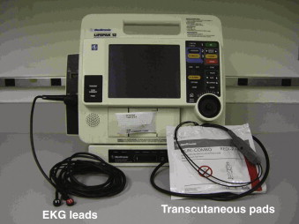

Figure 1

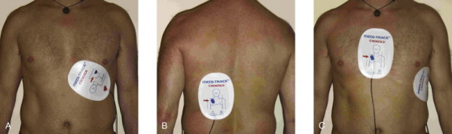

Figure 2. Correct placement of transcutaneous pacemaker electrodes. A and B, Anterior-posterior positions. C, anterior-lateral positions (see text).

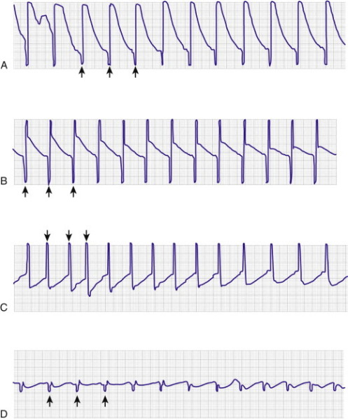

Figure 2A–C, The top three rhythm strips are taken from a standard wall-mounted ECG monitor. They all demonstrate large pacer spikes without capture. The underlying rhythm cannot be determined and could be treatable ventricular fibrillation. D, The bottom rhythm strip demonstrates a tracing on the same patient with the external pacer monitor (special dampening). Note that the pacing spikes are much smaller, and it is easily seen that the underlying rhythm is asystole, without pacer capture. The presence of a T-wave after the QRS complex is a good indicator of ventricular capture.

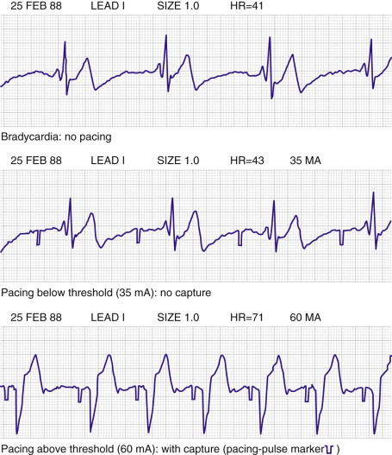

Figure 4. Assessing ECG capture with transcutaneous pacing. Note that the monitor has been adapted to accommodate the large pacing artifact so as not to obscure the underlying ventricular activity.

